Project Information Report - Godrej Azure

1. Project Summary
Sales Status: Sustenance
Construction Status: Under Construction Basement Stage

2. Configurations (all of them) & Pricing (in Crs.)
Configuration | Saleable Area/SBU Size (sq. ft.) | Agreement Value (Starting Price) | Pricing Range (Agreement Value + GST) | Pricing Range (Agreement Value + GST + SDR)
2 BHK Royale | 1020-1050 sq.ft. | 78.49 lakhs | 78.49 lakhs + 5% | 78.49 lakhs + 5% + 7%
3 BHK Elite | 1250 sq. ft. | 96.49 lakhs | 96.49 lakhs + 5% | 96.49 lakhs + 5% + 7%
3 BHK Royale | 1470 sq. ft. | 1.11 Cr. | 1.11 Cr. + 5% | 1.11 Cr. + 5% + 7%
3 BHK Grandeur | 1950 sq. ft. | 1.47 Cr. | 1.47 Cr. + 5% | 1.47 Cr. + 5% + 7%
4 BHK Duplex | 2722 sq. ft. | 2.10 Cr. | 2.10 Cr. + 5% | 2.10 Cr. + 5% + 7%

3. RERA: Possession & OC Timelines
- RERA Number: TNRERA/35/BLG/0354/2025
- RERA Certificate Link: https://rera.tn.gov.in/formcqr/f0bc5860-6641-11f0-82dc-1ff5a34f029d
- Possession Timeline As Per RERA (Month and Year): May 2030
- Possession Timeline Target As Per GPL (Month and Year): December 2027
- OC Timeline As Per RERA (Month and Year): December 2027
- OC Timeline Target As Per GPL (Month and Year): December 2027

4. 1% Payment Plan
- Payment Plan - 1% Payment Plan
- How it will work for this project (with demo illustration of the calculation):

2 BHK Royale Cost Sheet
Total Cost For Customer |  | 8424320.38
Total Agreement Value |  | 7904115
Milestone - 1% Payment Plan | % | 2BHK - 1050.17 sqft | Logic
Advance towards booking amount | 5% | 414966.04 | 5% Of Agreement Value + additional 5% GST of that value
Balance booking amount payable within 15 days | 5% | 414966.04 | 5% Of Agreement Value + additional 5% GST of that value
Within 60 days of booking or before 30th June whichever is earlier | 10% | 829932.07 | 10% Of Agreement Value + additional 5% GST of that value
On or before 5th Sept 2026 | 1% | 82993.21 | 1% Of Agreement Value + additional 5% GST of that value
On or before 5th Oct 2026 | 1% | 82993.21 | 1% Of Agreement Value + additional 5% GST of that value
On or before 5th Nov 2026 | 1% | 82993.21 | 1% Of Agreement Value + additional 5% GST of that value
On or before 5th Dec 2026 | 1% | 82993.21 | 1% Of Agreement Value + additional 5% GST of that value
On or before 5th Jan 2027 | 1% | 82993.21 | 1% Of Agreement Value + additional 5% GST of that value
On or before 5th Feb 2027 | 1% | 82993.21 | 1% Of Agreement Value + additional 5% GST of that value
On or before 5th March 2027 | 23% | 1908843.77 | 21% Of Agreement Value + additional 5% GST of that value
On or before 5th April 2027 | 1% | 82993.21 | 1% Of Agreement Value + additional 5% GST of that value
On or before 5th May 2027 | 1% | 82993.21 | 1% Of Agreement Value + additional 5% GST of that value
On or before 5th June 2027 | 1% | 82993.21 | 1% Of Agreement Value + additional 5% GST of that value
On or before 5th July 2027 | 1% | 82993.21 | 1% Of Agreement Value + additional 5% GST of that value
On or before 5th Aug 2027 | 1% | 82993.21 | 1% Of Agreement Value + additional 5% GST of that value
On or before 5th Sept 2027 | 1% | 82993.21 | 1% Of Agreement Value + additional 5% GST of that value
On Receipt of Completion Certificate | 35% | 2904762.26 | 35% Of Agreement Value + additional 5% GST of that value
On Notice of Possession | 10% | 829932.07 | 10% Of Agreement Value + additional 5% GST of that value
On Notice of Possession: Advance Maintenance & Sinking Fund Charges | 0% | 124999.63 | Advanced Maintenance & Sinking Fund Charges + 18% GST of Advanced Maintenance Value
Total Cost | 100% | 8424320.40
Additional SDR Charges of 7% at the time of possession
* This illustration is for representation purposes only. The actual calculation and monthly payout may vary depending on the (i) unit selected (ii) associated charges for that unit and (iii)
the offers available at project marketing office.

5. Floor Plans
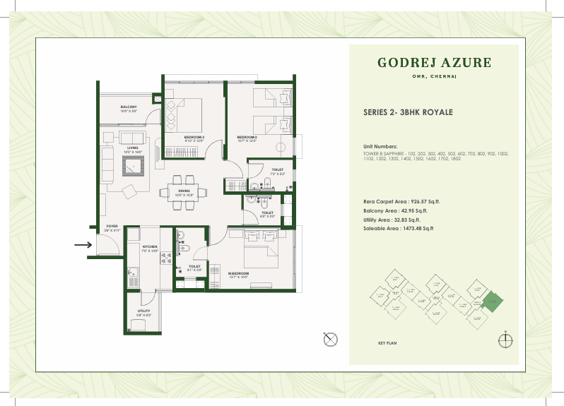
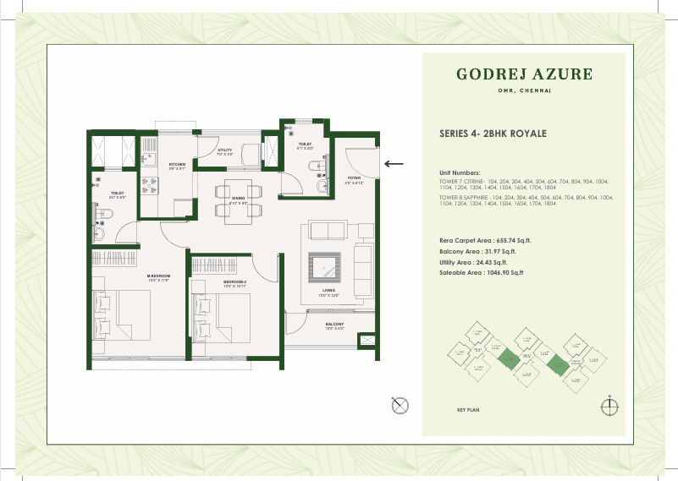

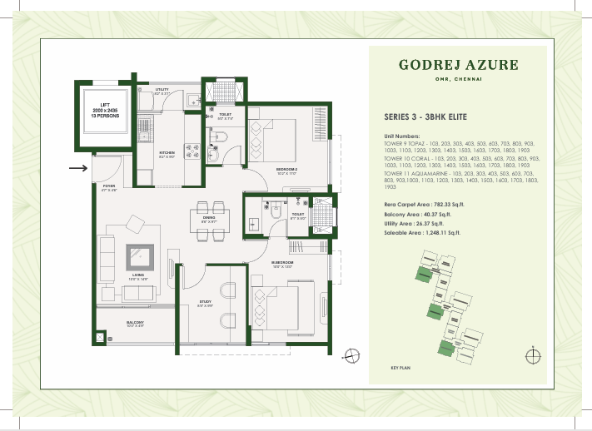
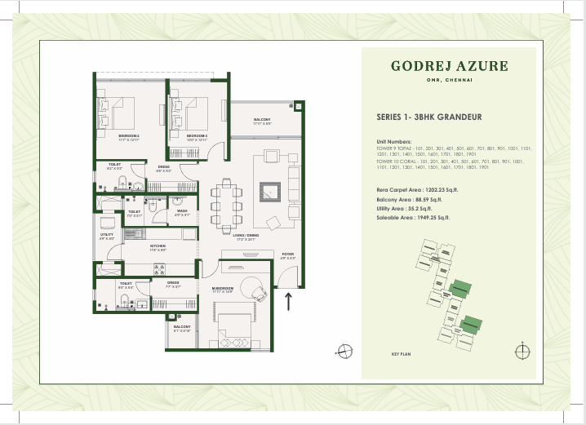
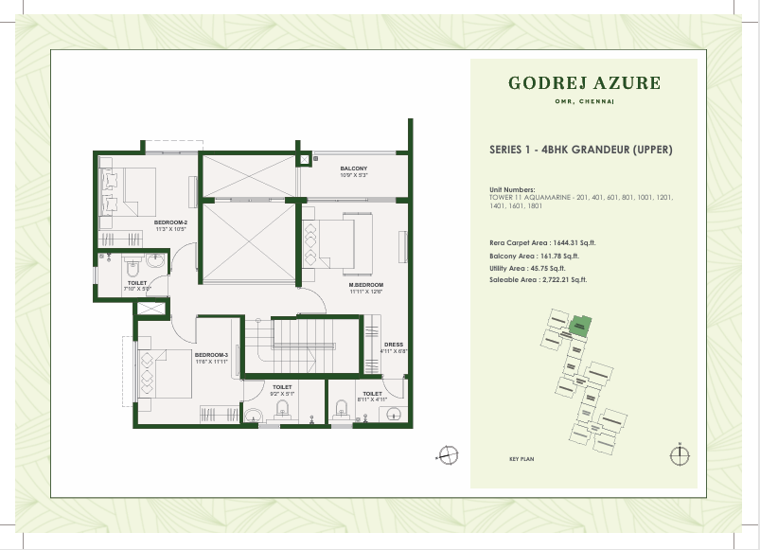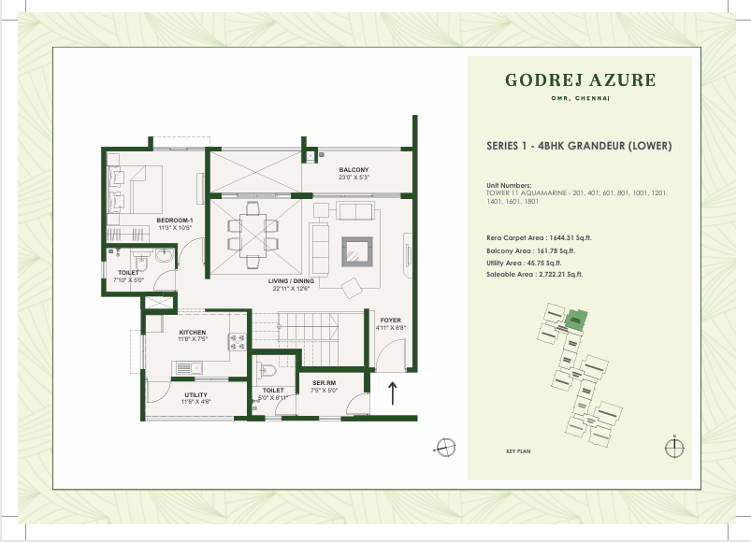

6. Location Advantages
- Schools & Colleges -
Hindustan University (0.95 Km) | 4 min* Drive
Sri Chaitanya School (1.9 Km) | 5 min* Drive
Gateway International School (1.4 Km) | 6 min* Drive
Hindustan International School (2 Km) | 6 min* Drive
Chettinad Sarvalokaa International School (3.9 Km) | 11 min* Drive
Jeppiaar Engineering College (7.3 Km) | 16 min* Drive
Satyabhama University (8.3 Km) | 17 min* Drive

- Hospitals –
Supreme Specialty Hospital (0.5 Km) | 2 min* Drive
Unittas Hospital OMR (1.5 Km) | 5 min* Drive
Dr. Kamakshi Memorial Hospital (3.0 Km) | 6 min* Drive
Chettinad Hospital (3.8 Km) | 16 min* Drive
Rainbow Children's Hospital (15.4 Km) | 36 min* Drive
Apollo Specialty Hospital (20.5 Km) | 45 min* Drive

- Offices / IT Hubs -
FL Smith Private Limited (2.9 Km) | 6 min* Drive
SIPCOT IT Park (3 Km) | 6 min* Drive
Virtusa Consulting Services Private Limited (4.4 Km) | 10 min* Drive
Pacifica Tech Park (4.6 Km) | 10 min* Drive
ETA Techno Park (5.1 Km) | 11 min* Drive
HCL Technologies (5.4 Km) | 12 min* Drive
The Times of India (7.5 Km) | 14 min* Drive
TCS (9.3 Km) | 20 min* Drive

- Malls / Supermarkets –
Reliance Smart Bazaar (0.3 Km) | 3 min* Walk
Aysha Hypermart (0.3 Km) | 3 min* Walk
Nilgiris Supermarket (0.8 Km) | 5 min* Drive
KPN (Kovai Pazhamuthir Nilayam) (1.3 Km) | 5 min* Drive
Grand Marina Mall (2.3 Km) | 7 min* Drive
Decathlon (3.5 Km) | 8 min* Drive
OMR Food Street (5.8 Km) | 12 min* Drive
Vivira Mall (6.9 Km) | 14 min* Drive
PVR Cinemas ECR (14 Km) | 20 min* Drive

7. Micro Marketing Understanding
- Phase 1 for the project, launched at 2015, has seen appreciation of ~100%, owing to infrastructure developments and rapid establishment of IT corridor for Chennai city on OMR, with major developments in Siruseri and ELCOT, former of which is roughly 2.5 Kms from our project location.
- Influx of cosmopolitan crowd, ranging from IT professionals to students pursuing higher studies from across the country, has ensured the consistent need for group housing for accommodation as well as investment opportunities.
- Upcoming Phase 2 Corridor 3 metro line which will run parallel to OMR ensures connectivity to key locations inside Chennai city.

8. FAQs Used By Sales & Pre-Sales Teams
Godrej Azure - FAQ
Question | Answer
- What is the distance from metro station? | - 2.5 Km (Siruseri metro station)
- What is the OSR (Open Space Reserved)? | - 1 Acre
- What is the size of ODU space and the entrance of it? | - ODU will have shaft size of 1525x750mm, and the opening size will be 750x1500mm.
- What is the staircases measurement? | - Staircases have a width of 1250mm.
- What is the elevator capacity and who is the service provider? | - 10pax Jhonson
- What type of doors are we using? | - Engg door
- Door width and height? | - Doors will have dimensions of 1100x2100mm.
- Is there any provision for mosquito mesh? | - No
- Types of tiles used in clubhouse, lobby and reception. | - Vertified tiles
- Are the doors facing each other? | - Yes
- Lift lobby and corridor width | - 6ft
- Number of Lifts? | - 2Nos
- Is there a glass partition in the toilet? | - No
- What is the source of water ? | - Ground water & Tanker
- Water Supply ? How many borewells are already functional and planned with depth. | - 3 Borewells
- Any concierge service to offer the residents | - No
- Is rainwater harvesting Provided in the project? | - Yes
- Width of the roads in the project | - 12m
- Distance between two blocks? | - Block to block, tentatively 13-16 metres distance. One block consists of 3 towers merged.
- What is the paint finish provided in the apartment? | - Texture Paint
- What is the size of the clubhouses and the bifurcation of each ? | - 11330sqft
- Can a customer pay 100% down payment upfront? If yes, what is the benefit he can get ? | - PACE interest rebate will be passed to the customer at 7.5% per annum
- How many changing rooms will be there near the swimming pool ? | - 6Nos
- What is the size of the guest rooms? | - No Guest Rooms
- How many entry points are there for the clubhouse? | - 2
- Does the club house have centralised AC? | - Yes
- What is the size & depth of the swimming pools? | - 17 m x 11 m x 4ft
- Whether it will be a heated swimming pool? | - No
- What Type of parking do we provide? | - Open/Closed
- What is the size of each parking we provide? | - 8ft/16ft
- What is the process of Parking alotment? | - 2 BHk - Open Parking, 2,5 BHk/3 BHk/3 BHK Large - Covered Parking, 4 BHK - Tandom Parking (1:1 for all )
- What is the scope of EV charging points and how many points will be there? | - Yes, In the designated spaces we have EV points
- How many parking? | - Single
- What is the total number of open parking ? | - All 2BHKs have open parking, and 3 and 4 BHKs will have covered parking.
- Can a customer buy additional car parking? | - No
- Can two flats be bought and combined into one flat? As a duplex ? | - No
- Are modifications permitted in the apartments? | - No
- Can buyer choose the flooring/finishing in case he wants ? | - No
- Ground level | - No need to disclose, but 6.37 metres Average Mean Sea Level.
- Is the title of the property clear? | - Yes
- Is the property freehold or leasehold ? | - Freehold
- Is there any legal cases pending and how will they affect the buyers decision ? | - No
- What is the UDS percentage ? | - 27%
- Under which development authority does the location comes in ? | - DTCP
- Where will the registration take place? | - Navallur
- Any previous litigation | - No
- Previous land owners (title history) | - Yes
- Height restrictions and building height | - In Phase-3, the three towers will be Basement+Stilt+18 floors, and in Phase 4, the towers will be Basement+Stilt+19 floors, with the Basement and Stilt area used solely for parking.
- Which banks are we planning on/timelines? | - All Major Banks (Godrej Capital, ICICI, HDFC, Tata Capital, Axis Etc..,)
- Franking or registration? | - Registration
- Stamp charges | - At Actuals (7 plus 2 )
- When can we share the legal set of documents? | - After 10%
- How deep is the excavation for basements | - No Need to disclose, just mention basement floor height
- How many trees and what kind? | - Total no. of trees in project- 120; OSR- 58, total shrubs in OSR-2532, Variants in shrubs- 27
- Property tax payable by customer post handover | - Yes
- FSI | - 2.3
- Zone | - Sesmic Zone -3
- Guideline values/ Composite Value | - 5500
- Documents for purchase in company name | - As per registration Process
- HUF purchase | - Yes
- Construction partner | - Not Decided
- Modfications (wiring, AC core cutting, power backup) | - No
- Construction type | - Maivan (No Block work)
- Glass thickness - balcony and windows | - Balcony will have MS Railing. The windows will have SGU 4mm and 6mm thickness.
- Wall thickness of external and internal walls | - External walls will have 160mm thickness and internal walls will have 90mm thickness.
- Common walls between towers/units | - No
- Sale agreement process for NRI or outstation clients? | - NRI as well as outstation clients will have to visit the site in-person to complete the registration.
- Engineering consultant | - Design Tree Consultancy
- Structural consultant/MEP consultant | - Design Tree Consultancy
- Height of boundary walls | - Boundary walls will have a height of 2.1 metres.
- The theme of the project | - Not Decided
- Floor to ceiling height | - All units will have a floor to ceiling height of 2950mm.
- Architect | - RSP
- Flood issue resolution | - YES
- Fire Extinguisher | - Yes
- Grade of concrete | - M30/M40
- Electricals | - All the wiring will be concealed copper FRLS(Fire resistant and Low Smoke) wiring, and all units will receive modular switches. In terms of power backup you will get DG power backup for your lift and common areas.
- Lifts | - All towers will be having two lifts, with one being passenger lift, and the bigger one being service lift.
- Vitrified tile | - In all units, the Living, Dining, Study, Bedrooms and Kitchen will have Vitrified Tiles. All Washrooms and Dado will have Anti-Skid Vitrified Tiles upto 2100 MM. Similarly, the Balcony and Utility space will also be having Anti-Skid Vitrified Tiles.
- Bathroom fittings | - All your sanitary fittings will be from American Standard.
- Paint | - Living, Dining, Study and Bedrooms along with the Kitchen, Utility and Balcony will have walls with Emulsion and Ceiling with OBD.
- Kitchen slab | - No
- Balcony | - Yes
- Are we providing Intercom in the apartment door? | - No
- Do we provide AC points? | - Yes
- Do we have a gas leak detector in the kitchen? | - Yes
- Where is the STP located? | - Basement
- Who will maintain the property ? | - Registered Association
- What type of security allignment do we provide ? | - The community will have MyGate application for security purposes.
- Will there be 100% percent power backup/ Capacity ? | - Yes
- Do we have WTP in the project? | - Yes
- Are solar options provided in project? | - Yes - Top most 2 floors in each tower
- What type of door locks will be provided at main door ? | - It will be an engineered door frame and flush panel door with Veneer on both sides.
- Is there a provision for piped gas? | - NO
- Who will provide the electricity? | - TNEB
- What is the delay /outstanding payment penalty? | - After 15 days of defualt intreset payment 16th day basis on SBI MCLR rate + 2% on the outstanding amount
- Does the customer have an option to customise the location of the electrical points ? | - No
- What is the size of the banquet hall ? | - 150
- Garbage chute | - Yes
- When is the construction starting at site? | - Oct-25
- What is the booking cancellation clause ? | - 10% Deduction
- What is the loading percentage ? | - 68%
- What cheque name has to be favoured for EOI ? | - GSSPDLGAPL collection account for Godrej Azure phase 3 & 4
- Can a customer buy multiple apartments? | - Not more than 2 units
- What is the mode of payment? | - DD/RTGS./NEFT/Card Swipe/UPI
- What is the society office location? | - Block 1
- What’s the Electricity load? | - 4 BHK EB - 86 kW & DG - 3 kW  3 BHK & 3 BHK L EB - 6 kW & DG -– 1.53 kW  Compact 3 BHK EB - 5 kW & DG - 1.5 kW  2 BHK EB - 5 kW & DG - 1 kW
- Is payment schedule flexible and whether it is construction linked or time linked ? | - 1% plan
- SBA to Carpet Ratio. | - 68%
- Which brand of electrical fittings will be provided and who will be the service provider | - Brand: Panasonic Roma, Service provider not confirmed
- Basement Floor height | - 3.7 metres/12.1 Feet
- Provision for Borewell | - Yes
- Bathtub Space | - No
- Antiflooding Provisions | - Yes
- Water Connection Pipes | - CPVC/UPVC Pipes
- Floor to Celling height | - 9.6 Feet
- Steel Brand ? | - Tata Steel or reputed brand - Primary steel

1% Plan FAQ

Godrej Azure – 1% Payment Plan FAQ
Question | Answer
- How much will my initial booking amount be? | - Initial booking amount will remain 5% of your property cost.
- How much am I paying till possession? | - Till your actual terrace completion, you would have paid only 55% of your property cost. Balance 45% will be at possession.

9. Legal Disclaimers
RERA Registered. RERA No: TNRERA/35/BLG/0354/2025; Project: Godrej Azure, Survey Nos. 282, 283/1, 284/1, 284/2A, 281/1B1A, 281/1B2, 283/2 and 284/2B Padur Village, Tiruporur Taluk, Kancheepuram District and survey Nos. 222/2, 224/1, 224/2, 227/1A, 227/1B, 227/1C, 227/2A, 227/2B, 227/2C, 227/3, 225/1, 225/2, 226/1 and 226/2 Kazhipattur Village, Muttukadu Panchayat Union, Kancheepuram District. Website: https://rera.tn.gov.in
The official website of Godrej Properties Ltd. is www.godrejproperties.com. Please do not rely on the information provided on any other website. The sale will be subject to the terms of the application form, allotment letter and Agreement for Sale. The specifications/amenities mentioned in the Agreement for Sale and/or uploaded on Karnataka RERA website shall be final and binding on the Developer and Purchaser. Recipients are advised to apprise themselves of the necessary and relevant information of the Project prior to making any purchase decisions. *This refers to the payment plan offer. Please refer to payment terms as mentioned in the AFS. Basis sole discretion of the developer. Limited time period offer. Date of publication 14th April, 2026.

